**Q. Migratory Birds**

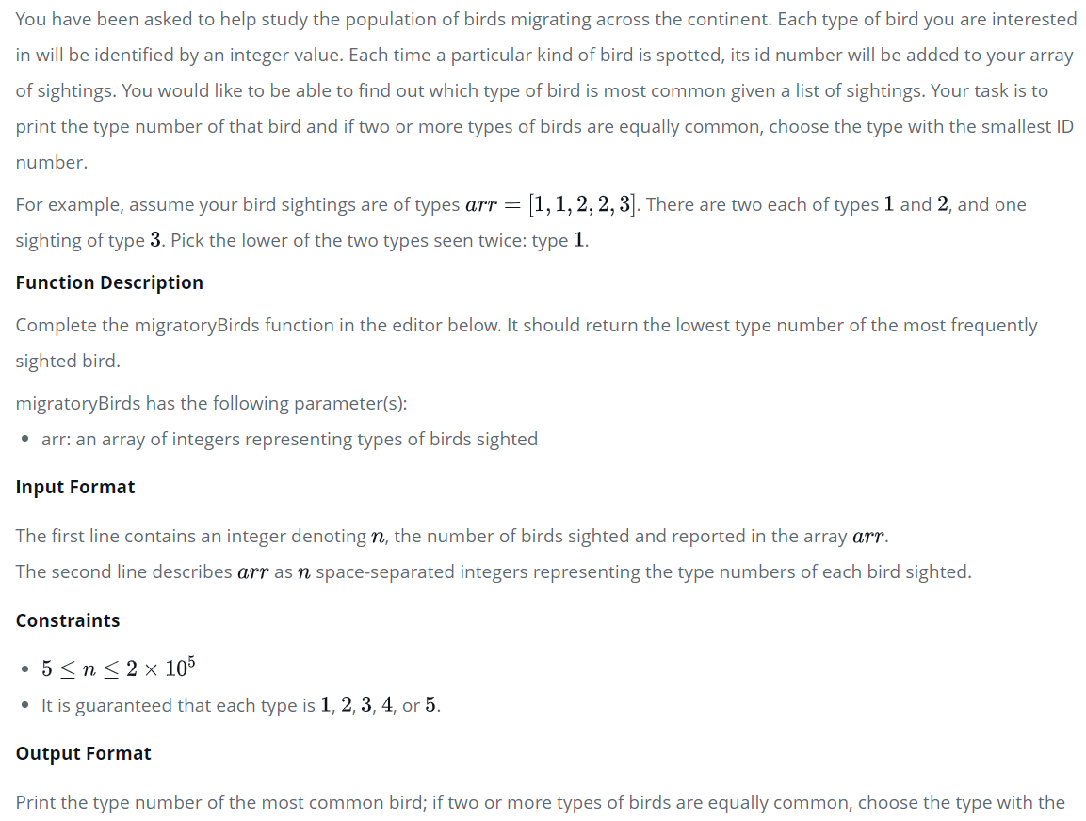

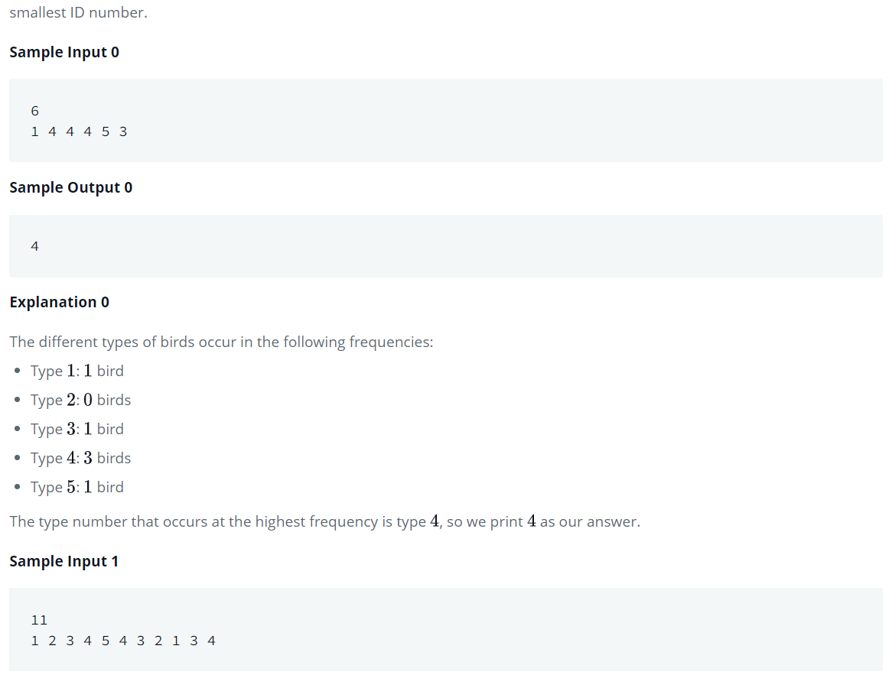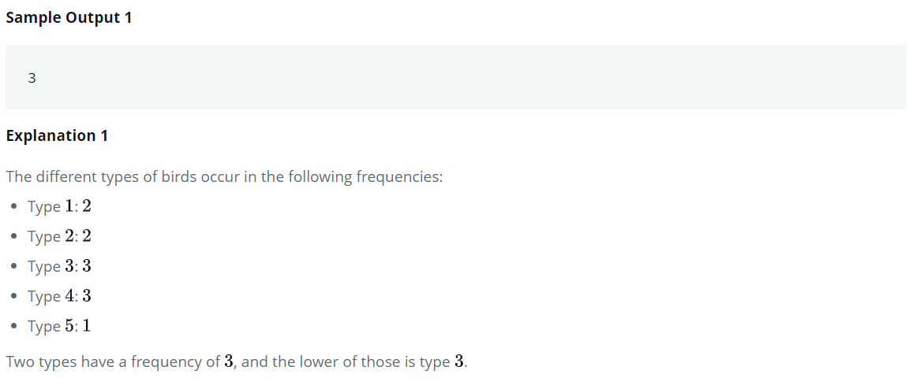

Python Program

n = int(input())  
ar = list(map(int, input().split(**" "**)))  
  
  
def migratoryBirds(arr):  
 typecount = [0 for i in range(5)]  
 for i in arr:  
 typecount[i-1] += 1  
 max_count = max(typecount)  
 for i in range(5):  
 if typecount[i] == max_count:  
 return i+1  
  
print(migratoryBirds(ar))